Sequential 7-Segment Display Controller Using NE555 Timer

This project showcases a sequential display system built using the NE555 timer, where outputs are activated one after another in a continuous loop.

In simulation (Circuit Wizard), the circuit drives multiple 7-segment displays to spell the word “POST” by activating each display sequentially. The timing signal is generated by the NE555 in astable mode, while a chain of transistors (Q1–Q4) controls which display is active at a given moment.

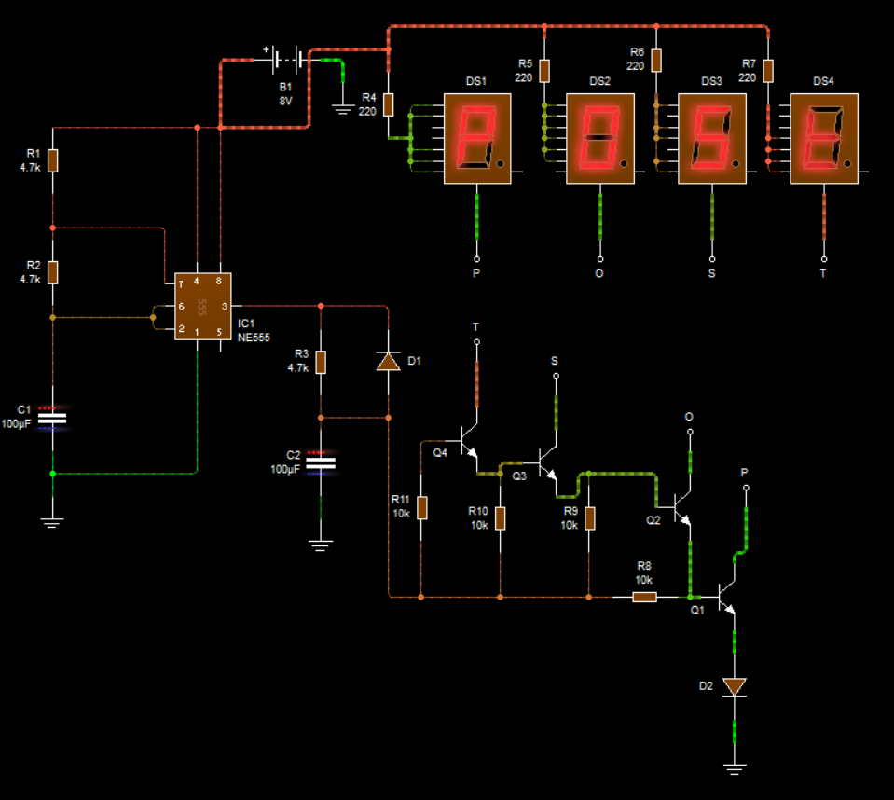

How It Works:

- The NE555 timer produces periodic pulses (clock signal).
- RC components (R1, R2, C1) define the speed of switching.
- Transistors act as switching stages, enabling one display at a time.
- Each stage corresponds to a letter: P → O → S → T.
- The sequence repeats indefinitely, creating a looping display effect.

In real implementation, only 2 segments were available instead of full 7-segment displays.
As a result:
The system could not fully display “POST”
It instead showed a simplified output like “ON”
